Module A: Speed Test
  - Web Technologies

Submitted by:
Thomas Mak
David Cantwell
Chorng-shiuh Koong
Siew Hwa Kang
Seunglyul Ryu
Bruno Medeiros
Gilles Granger
Ryoju Ohata
Zhang Ling

Contents
Contents 2
Introduction 3
Part A 3
A1: Masking Image (Easy) 3
A2: Vectored artwork (Normal) 3
A3: Double Exposure Effect (Easy) 3
A4: Instagram Grid (Normal) 4
A7: Apply Background (Easy) 4
A8: Add a filter (Easy) 4
Part B 6
B3: 9-Images (Medium) 6
B7: Korean flag (Normal) 6
B8: Rotating Star (Easy) 7
B10: 5 Stars Rating Animation (Easy) 7
B13: Accessibility (Medium) 8
Part C 9
C2: Spotlight (Medium) 9
C4: Notebook (Difficult) 9
C16: Drawing tool (Medium) 10
C25: Mouse style (Easy) 11
Part D 12
D7: Number of Days (Easy) 12
D15: Write a Secure Login (Difficult) 12
Part E 13
E8: Modal POST (Difficult) 13
E12: Change Login path (Easy) 13
Instructions to the Competitor 14
Equipment, machinery, installations, and materials required 14
Marking Scheme 14

Introduction
In this speed test project. You only need to complete the randomly picked one during the competition. Please follow the instruction to know which one to implement.
For each Easy, it worths 0.5 point.
For each Medium (Normal), it worths 1 point.
For each Difficult (Hard), it worths 1.5 point.
Please put your files in /XX_module_a/ and with the task ID as folder name, e.g. /XX_module_a/A1/
The XX is the workstation number.

Part A

A1: Masking Image (Easy)
Open the provided image (flower.jpg) in an image editor and change the image into greyscale. Once completed, you need to mask the flower and place it on the background image (background.jpg) provided. Save your new image as XX_A1.psd and XX_A1.jpg

A2: Vectored artwork (Normal)
Create the following icons with reference to the image provided (icons_sample.jpg).
Icons should be recreated as a vectored artwork. Once completed, save your working file as XX_A2.ai and XX_A2.jpg

A3: Double Exposure Effect (Easy)
Create a similar double exposure effect as in the example below. Save a JPEG file called double-exposure.jpg.
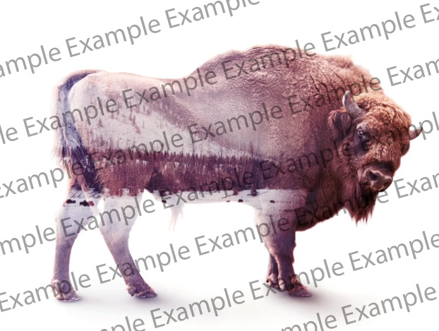

A4: Instagram Grid (Normal)
Add a profile pic (profile-pic.jpg), username(pedro.souza), and add 9 pics in the feed in the Instagram Grid mockup (Instagram-Profile-2022.psd) and then put it into the iPhone mock (iphone-mock.jpg). Save the output into a JPEG file called instagram-grid.jpg

A7: Apply Background (Easy)
Apply the background image 2.jpg to the image 1.jpg
- Submit as result.jpg. (0 points when using sample.jpg from the media file)
1.jpg + 2.jpg | Result = sample.jpg
 | 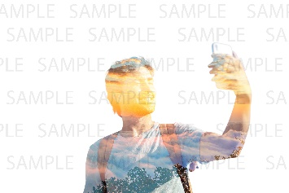

A8: Add a filter (Easy)
- Add a noise filter to the image plane.jpg. Submit as result.jpg. (0 points when using result.jpg)
plane.jpg | result.jpg
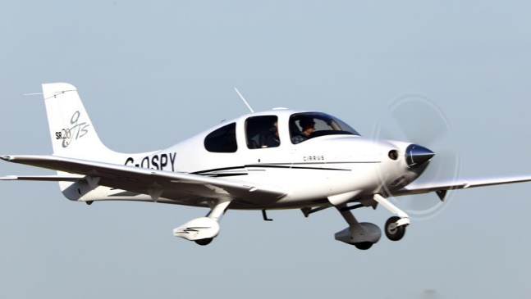 | 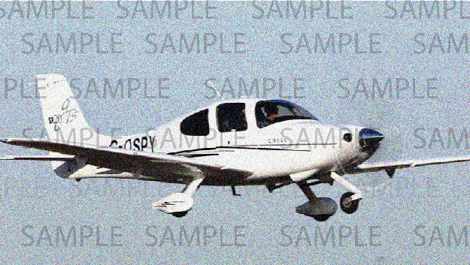

Part B

B3: 9-Images (Medium)
Create an image grid container using CSS only. The maximum capacity of the container is 9. If the number of images is overload, the number of excess-images is displayed in the last grid.
You can only edit the style.css file.
Tips: the “Remove First Image” button is the function provided.
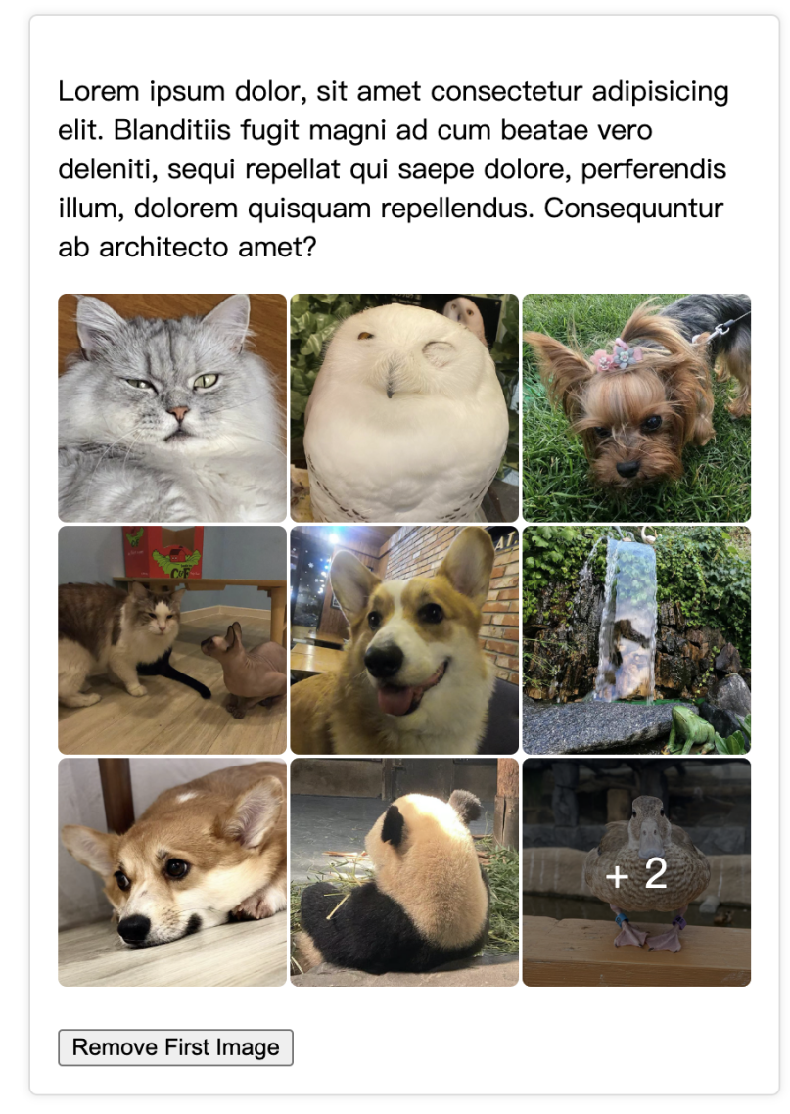

B7: Korean flag (Normal)
Please, write the CSS code to create the korean flag like the one you can see here.
(No media files)



B8: Rotating Star (Easy)
Please, draw a yellow rotating five-pointed star using CSS.
(No media files)

B10: 5 Stars Rating Animation (Easy)

Create a 5 Stars Rating UI using the provided "stars.png" image. (Use HTML/CSS only)
When you hover your mouse over a star, an animation that smoothly fills in from the left to the star's score proceeds.
Score 0.5 point unit: 0, 0.5, 1, 1.5, 2, 2.5, 3, 3.5, 4, 4.5, 5
Example

Refer to animation.mp4 for the star filling animation.

B13: Accessibility (Medium)
Any time you are developing a web site or web application you should ensure you follow any applicable guidelines for accessibility. This will help ensure it can be used by people with disabilities including visual disability.
You have been provided with a single HTML page named accessibility.html in the provided-assets folder that has five common accessibility issues. Your task is to identify and implement a fix for these issues.
Save your solution as accessibility-fixed.html inside of a new folder.

Part C

C2: Spotlight (Medium)

Referring to the given media, you are required to show a spotlight over an image when the mouse moves over the image. The spotlight should be white in color, translucent, and has some blur effects. When you move the mouse wheel up or down, the size of the spotlight will increase or decrease respectively. Your program should detect a minimum size of 10px for the dimension of the spotlight. At all times, ensure that the mouse cursor is in the middle of the spotlight.

C4: Notebook (Difficult)
You should develop based on a page which is provided in media files. Develop a function when you click the “Render” button, the selected text should be marked(“yellow” background and “red” foreground),and when you mark other text, the previously marked text should be retained.
You can only edit “index.js” file.
You can not use JavaScript libraries.
Select Text:
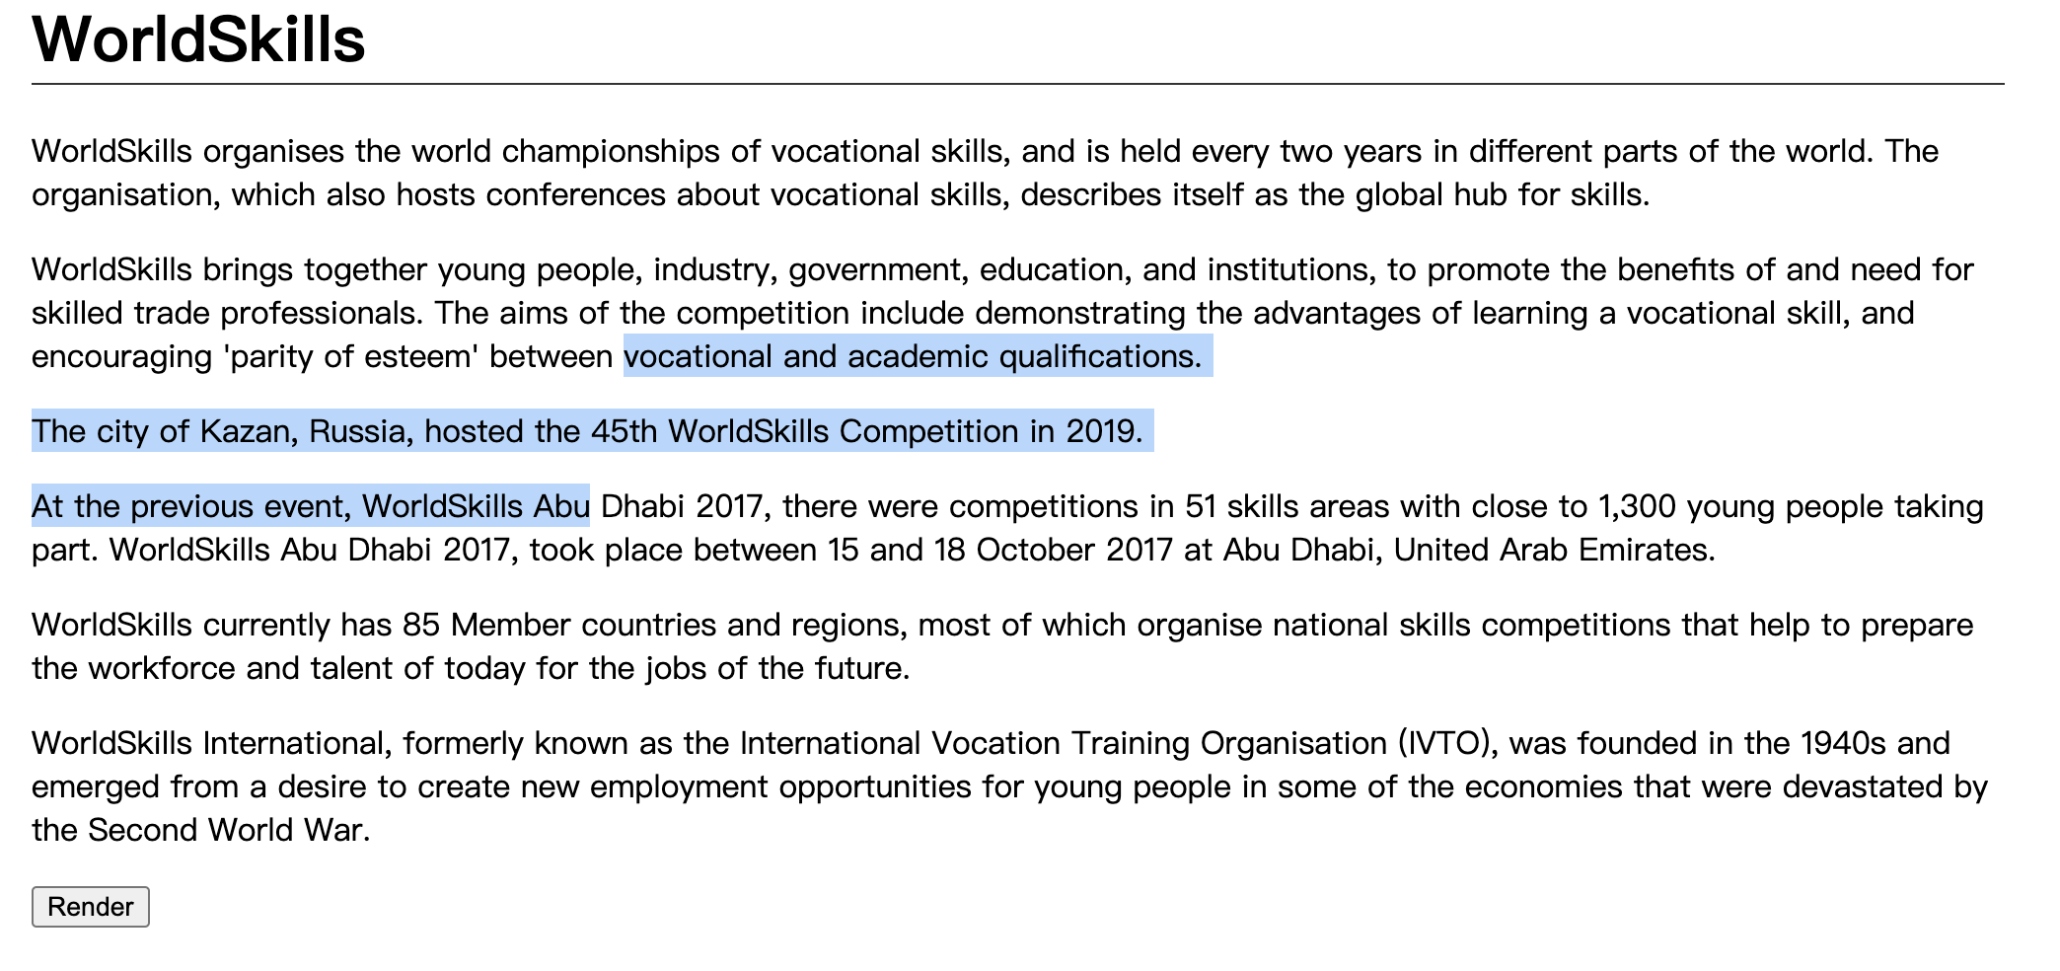
Mark Text:
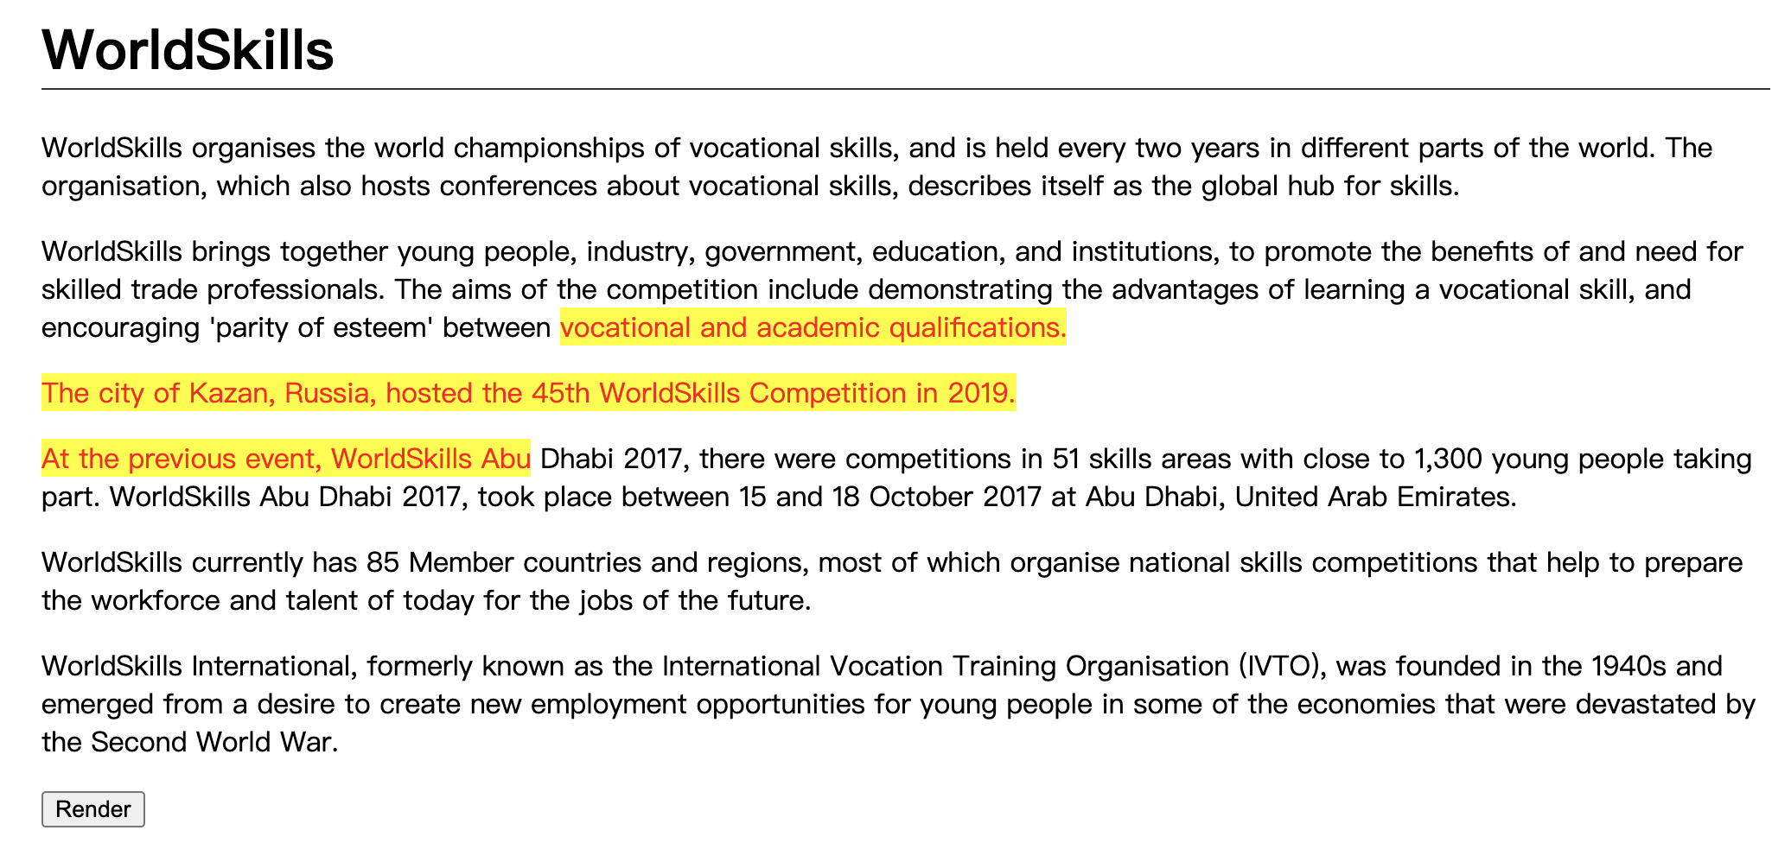
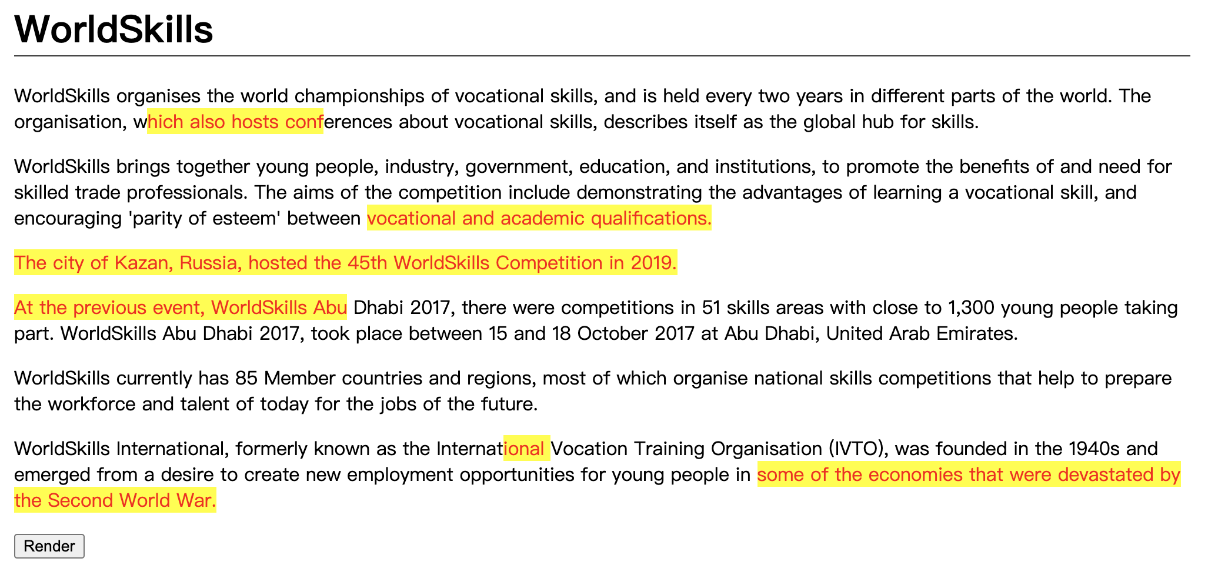

C16: Drawing tool (Medium)
You are to create a client-side drawing tool, with a canvas on which one may freely draw.
- Five different colour buttons are to be provided for the user to select from
- The default canvas size is to be 300px by 300px
- Clicking and dragging the bottom-right corner of the canvas is to modify the canvas size
- 1 button to save the drawing as a jpg and 1 button to save the drawing as a png onto the client-side computer are to be provided
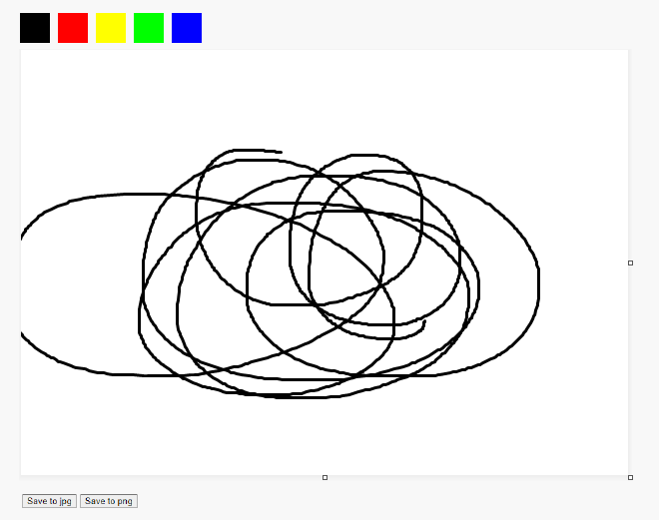

C25: Mouse style (Easy)
Change the style of the mouse.
- When clicked, it should display an animation.
See mouse.mp4 in the given folder to understand the functionality.


Part D

D7: Number of Days (Easy)
Show the number of days between two given dates. The user must enter as data in the input date. The date is in YYYY-MM-DD (ISO8601) format.
Input: index.php?date1=1992-07-19&date2=1992-07-22
Output: 3 days

D15: Write a Secure Login (Difficult)
Security is a key consideration when writing web applications. In this task, you are provided with a small website that includes an authentication system. However, upon reviewing this code you notice several issues including:
- Passwords are stored in plain text
- Cookies contain information about the user
- There is no accommodation for SQL injection attacks
- There is no accommodation for brute force attacks
- No feedback is provided to the user on bad logins
Your task is to fix the highlighted issues with the existing system to make it more secure.
You have been provided with a basic user table for your database, but you will need to add fields to implement your updates.
The functionality for checking if a user is logged in as well as handling the login request is also provided but is also insecure.
When you are finished, please ensure you provide the judges with valid login information for your secure website!

Part E
When creating database, please name your db speed_test_EX, where X is the task number. Please use username: admin, password: admin for all the tasks in part E. If we cannot login to check, mark is deducted.

E8: Modal POST (Difficult)
Create a theme where you can create a customizable header and also where you can display all posts and when you click view post a floating window will appear with the content of the post.
- See theme_post_modal.mp4 in the given folder as an example.

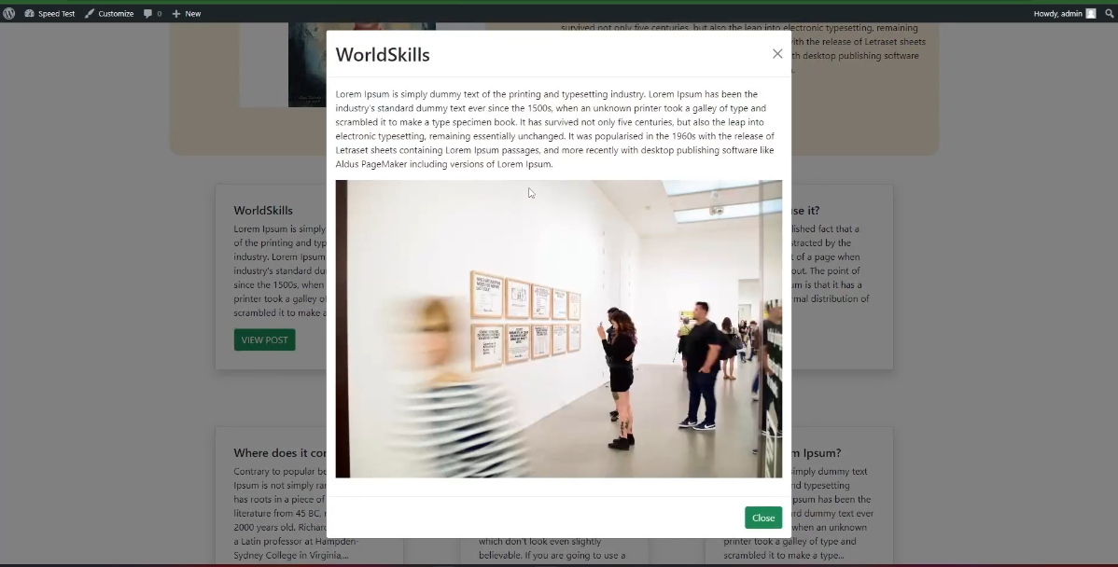

E12: Change Login path (Easy)
Change the wp-login.php into member-login.php and keep the Wordpress login still working as usual.

Instructions to the Competitor
- Please ensure your name the files according to the description and organize your files for assessment.
- All assessment is done on server. No assessment process in workstation.

Equipment, machinery, installations, and materials required
ITEM | quantity | material | description | notes
- | - | - | - | -

Marking Scheme
 |  | Communication and Presentation | Design | Layout | Front-end | Back-end | CMS | Total
A1 | Design | 0.5 | 4 | - | - | - | - | 4.5
A2 | Layout | - | - | 4 | - | - | - | 4
A3 | Front-end | - | - | - | 4 | - | - | 4
A4 | Back-end | - | - | - | - | 2 | - | 2
A5 | CMS | - | - | - | - | - | 2 | 2
 | Total |  |  |  |  |  |  | 16.5

